Visual interfaces effect on player performance in virtual reality

A dissertation submitted in partial fulfilment of   
the requirements for the degree of   
MASTER OF ENGINEERING in Computer Science

In

The Queen’s University of Belfast

By  
Timothy O’Neill

06/03/2015

Contents

Acknowledgements 3

Abstract 4

Introduction 5

Background 5

Visual Interfaces. 5

Interfaces part of the game narrative. 5

Interfaces not part of the game narrative. 6

Examples of visual interfaces in virtual reality games. 6

Euro Truck Simulator 2. 6

Half-life 2. 7

War Thunder 7

Surgeon Simulator 8

Dead space interface post mortem 8

Previous Studies. 9

Evaluating Interfaces. 9

Evaluating two interfaces for searching a database [9]. 9

Conclusions 10

Use to this research. 10

Driving an armoured vehicle using a head-mounted display [10]. 10

Conclusion 11

Use to this research 11

Evaluating three different interfaces for a mobile game [8]. 11

Conclusion. 12

Use to this research 12

Investigation Method 13

Pre Experiment Questionnaire 13

Instructions 13

Calibrate Oculus 14

Game Demo 15

Game Scenario 15

Metrics to be collected 17

Post experiment questionnaire. 17

Results and Analysis 19

Conclusions 20

References 21

Appendices 22

Acknowledgements

Abstract

Fully immersive experiences into virtual reality (VR) will become common place in the next decade, with that comes the need for research to make sure that these experiences are the best they can possibly be, Visual interfaces used in games are key to tracking a players progress, providing feedback to the player and helping them navigate the environment, Using a fabricated scenario created in Unreal Engine4 [1] in conjunction with the Oculus rift [2], we will track metrics and then ask the participant to fill in a questionnaire to discover what categories of Visual interfaces work best in the oculus rift compared to a traditional gaming setup, existing games have made changes specifically for VR however most have been done as side projects to main development and such are not their most optimum, This paper will be a useful resource for any developer tackling VR development specifically with any design and implementation choice they need to make on Visual Interfaces.

Introduction

VR has been in existence since the 1950’s primarily used by the military for training or hobbyists to escape into a virtual world, it has been growing steadily over the past few years with technology becoming cheaper and more accessible, and this has cumulated with VR Company Oculus being bought by Facebook for two billion dollars [12], funded by Facebook Oculus will release the first consumer affordable VR device the Oculus rift. Many large companies are now picking up VR development even going as far as developing with VR as their primary platform for playing the game such as EVE Valkyrie [13], this paper in particular focuses on the importance of the use of visual interfaces to provide feedback to players on their performance, the results of this paper will guide developers into the best interfaces to use to make sure the player while enjoying the immersive nature of VR is still able to play the game to the best of their ability.

Background

Visual Interfaces.

Games have always required ways of giving feedback to a player, Visual interfaces play a key role in performing this task, While other interfaces such as audio and haptic exist most games still use visual interfaces for the majority of their feedback. They can be broken down into four categories [3].

Interfaces part of the game narrative.

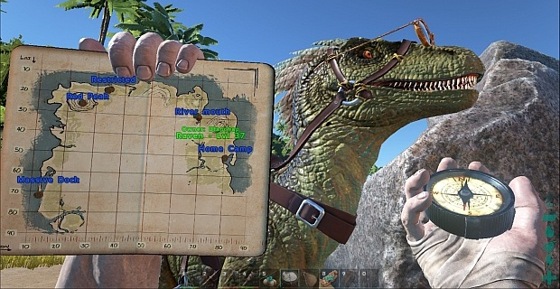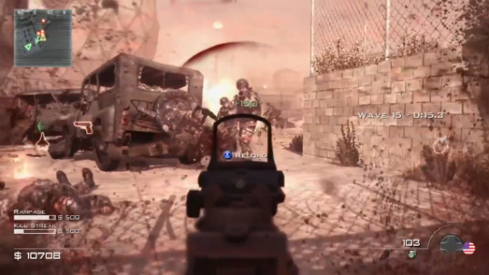Diegetic interfaces are a part of the characters story, they tend to be presented with an animation of a character raising a map or opening a hologram menu as not to interrupt their immersion in the game world. An example of this is Ark survival Evolved which uses a diegetic interface for the players map and compass.

Figure 1. Ark Survival Evolved

Figure 2. Call of duty

Meta interfaces are still a part of the avatars narrative, they take the form of temporary information such cornering suggestions in a rally game. An example of this is call of duty that uses Meta interfaces to show where the player is being attacked from as can be seen in Fg 2, this draws the player further into the game world by showing a blood splatter and reducing visibility.

Interfaces not part of the game narrative.

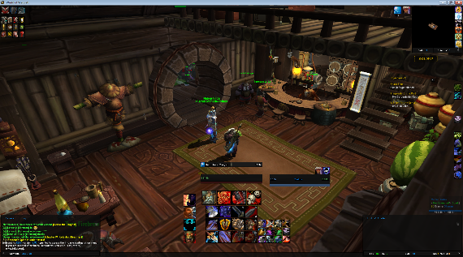Non Diegetic interfaces are not apart of the avatars narritive but are visible to the player they provide information such as health, ammo count or in the form of a minimap for the player. A good example of this is world of warcraft that shows the player health, mana, spells, map and much more as shown in Fg 3.

Figure 1. World of Warcraft

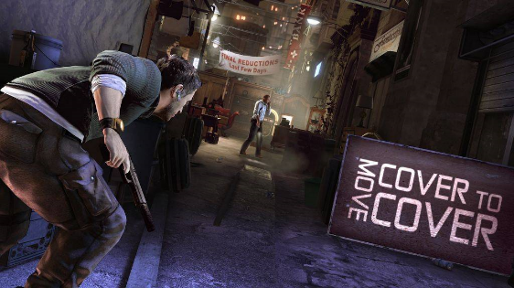Spatial interfaces are used when there’s a need to break the narrative in order to provide more information to the player than the avatar would be aware of, they take the form of glowing trails on the ground or instructions on walls. An example of this splinter cell conviction that uses spatial interfaces to display the current task to the player as seen in Fg 4.

Figure 2. Splinter Cell Conviction

Examples of visual interfaces in virtual reality games.

Many early adopters and indie dev’s are already creating and changing existing games and experiences for virtual reality this section outlines some of these and the adjustments they have made for virtual reality[4].

Euro Truck Simulator 2.

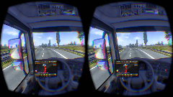Euro truck simulator 2 places the player in the position of a truck driver in Europe requiring them to deliver cargo, the game helps the player perform this task using several interfaces, in the normal game is uses extensively non diegetic interfaces for the sat nav of the vehicle, delivery details, email, money etc. It also uses spatial elements such as road signs and indicators on other cars, In the oculus version of the game the developers stripped out the non-diegetic sat nav and turned it into a diegetic interface by placing it constantly on the dashboard of the vehicle allowing the player to naturally look at it any time, they also turn the general interfaces into a floating diegetic interface that hovers above the steering wheel, all other spatial elements remain the same in the game.

Figure 3. Euro Truck Simulator 2

Half-life 2.

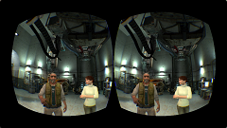Half-life 2 is a first person shooter, it extensively uses non-diegetic interfaces to help the player keep track of their ammo health and Armor, it also uses Meta interfaces to help the player identify where an enemy is shooting them from, Half-life is set up two ways depending on the controller used in conjunction with the oculus rift, Using just the oculus rift on its own the developers left everything as is, however if the user is using a controller such as the razer hydra [5], they remove all the non-diegetic interfaces for ammo, health and Armor and replace them with diegetic ones on the players wrist and gun, the meta interfaces are unchanged.

Figure 4. Half Life 2

War Thunder

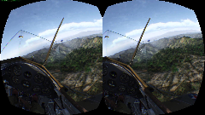War Thunder places the player at the controls of a fighter plane participating in multiplayer dogfights, it primarily has a cut back interface but has some key non diegetic elements, and the planes speed, altitude and throttle are all displayed, a reticule for where the gun of the plane is aiming is displayed, scores of each of the teams are also displayed in a similar manner along with a mini-map of the battlefield, Spatial indicators appear to help identify targets and their relative distance, In the oculus rift they strip away all these interfaces, It uses the diegetic interfaces of the cockpits dials to display speed, altitude, and throttle, The game also gets rid of score board and places it in a meta interface that has to be brought up by button press, The spatial elements are also replaced with meta interface arrows that point at the enemies in your vicinity.

Figure 5. Warthunder

Surgeon Simulator

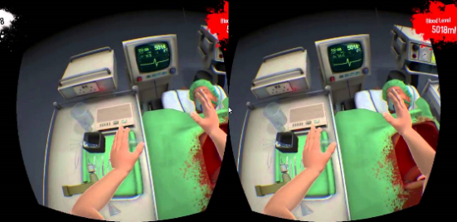Surgeon Simulator puts the player in charge of various surgical procedures, the player has to perform the surgery as quickly as possible while keeping the patient healthy represented by blood loss, the Time and amount of the patient have are shown twice with 2 interfaces there is a spatial interface of a heart monitor in the game world that shows both the blood level and time, there is also a non-diegetic interface that displays the blood level and time constantly on in the top right and left respectively.

Figure 6. Surgeon Simulator

Dead space interface post mortem

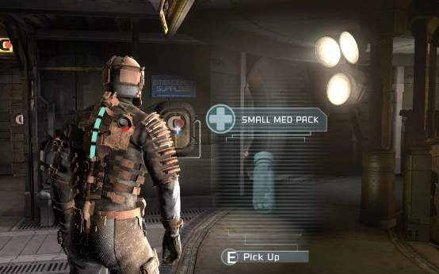The Dead space game series was famously the first to use a fully diegetic interface Fg 9, the following section is from a talk given by Lead UI Designer Dino Ignacio at GDC 2013 [6].  
The designers wanted the game to be as immersive as possible due to it falling into the horror genre, This meant their choice was to implement a fully diegetic interface to the user for game feedback, They also made the decision of the players character being view at all times, even if it is just his arm, in Fg 9, you can clearly see the players health represented by the light blue tube on the avatars back. However in the third instalment of the game the designers wanted to expand the crafting system in the game to include further mechanics to allow the player to change their weapons.

Figure 7. Dead Space 1 Screenshot

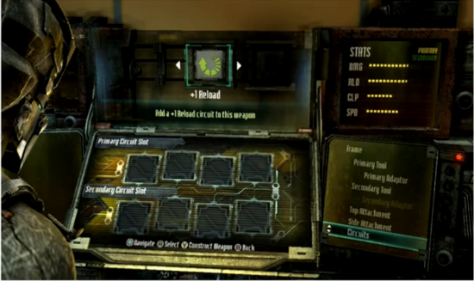The first iteration of the design is shown in Fg 10, it was a diegetic interface conveying all the various parts of putting together a gun or upgrade, Although this fitted their mission statement of always using diegetic interfaces and having the avatar in view, It soon became apparent that the interface crippled the usability of the game, developers opted for using the in game debugging console commands instead of the interface because it was so unusable.

Figure 8. Initial bench design DS3

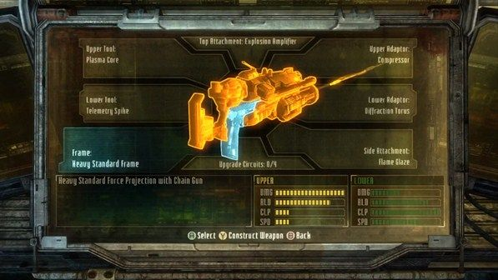Eventually the final design came together as shown in Fg 11, it is non diegetic and vastly improved the ability for the user to interact and be able to use the interface in order to complete the task of building a weapon, this is a good example of previous issues that games have faced long before the advent of virtual reality, it also helps to reinforce the importance of this research through a solid example where design and implementation compromises had to be made to enable the player to be able to accomplish a goal.

Figure 9. Final bench design DS3

Previous Studies.

The oculus rift offers interaction from a first person perspective from previous case studies into the First person shooter genre [7] we know the following.

Figure 10. Distribution of information amongst the visual, auditory and haptic channels

From Fg 12. We can clearly see that a vast majority of feedback to the player in a first person game is done through visual interfaces, this is very important for virtual reality were it is primarily a first person experience, this shows the importance of this research into user interface (UI) design for games.

Evaluating Interfaces.

The following section outlines empirical papers that have done experiments into interfaces and user performance it discusses their findings and any pitfalls they fell into.

Evaluating two interfaces for searching a database [9].

The paper outlines two alternative user interface designs that are exposed to user testing to measure user performance in a database query task.

They create two interfaces for a database one comprising of a drop down box and another a dialogue box, they are interested in the time taken by each user to look up a randomised phone number using the interfaces. Firstly experts with nine or more years of experience were consulted to make estimates on how much time would need to be taken for each interface, in addition the experts were split into three groups, hot, warm below is outlined what affect this had on their exposure to the system.

* Hot – Access to the system for longest time period.
* Warm – Access to the system for a mean of the hot and cold time period.
* Cold – Very little access to the system for a time period.

The study also uses GOMS (Goals, Operators, Methods, and Selection rules) [11], GOMS is analysis tool for creating estimates of user performance, with the estimates from the expert group and the GOMS user testing was performed, this involved getting twenty students to use the software, the users had no experience but were shown how to use the interfaces and allowed to practice.  
At this point a cost benefit analysis was performed it was noted that expert analysis would have a higher cost to it than a student’s group as would the cost of having to perform GOMS analysis.

Conclusions

The paper concludes showing that user testing performed very closely to the “Hot” expert estimate, this shows that user testing is an accurate measure of user performance, however the testing is not always a perfect predictor of real world performance. It was also noted that hot estimates were as accurate as user testing but cost substantially more.

Use to this research.

The paper helps identify the need for an experiment to evaluate user performance it shows that user testing is the best means to attain meaningful data, although it does warn of the variability of testing and that a large sample should be attained to get a good average, it also shows time as a heuristic to track when evaluating two interfaces which will be beneficial to my experiment.

Driving an armoured vehicle using a head-mounted display [10].

This paper outlines an experiment for testing the effectiveness of head-mounted display (HMD) and a head tracker for driving an armoured vehicle compared to traditional direct view and periscope view.

The main focus was to compare the HMD system to the periscope view direct view was used as a control for the experiment, the participants were then tasked with driving the vehicle over rough and paved terrain, on the paved terrain the vehicle had to pass through a funnel of cones and slalom, the number of pylons knocked over were counted.

Conclusion

The experiment showed that the user performance with the HMD was better than that of the periscope system on both paved and rough terrain, HMD users also performed faster in some sections of the off road, although it is mentioned that even better results could be attained for the HMD if the drivers were more experienced with the technology.

Use to this research

This research highlights the importance of hen investigating HMD technology such as the Oculus to compare to the existing standard, In the case of this paper it may be beneficial to run the experiment both on the Oculus and a standard computer setup and compare the results to see if they are comparable or vastly different.

Evaluating three different interfaces for a mobile game [8].

The paper implements three user interfaces for a scroll shooter video game on an iPod Touch and test their effectiveness and how enjoyable they are to the user.

The game is structured to have three interfaces, simulated button, touch gesture and accelerometer, seven levels of difficulty are defined for the player to play, and over the course of the game the following metrics are tracked.

* Total time played.
* Number of projectiles fired.
* Number of player projectiles that connected with enemy ships.
* Number of enemy ships destroyed.
* Time the ship spends moving in each of the eight directions.

The game screen was segmented into nine distinct zones, the amount of time the player spends in each zone is also tracked.

During the test sessions the tester is given a questionnaire prior to participating in the experiment the first questionnaire is there to ask some general information on the user, the users are also asked about their experience of with the videos games on mobile platforms, the participates are then allowed to practice the game for a maximum of three minutes, they then plays the full game with a specific interface. A questionnaire is then filled in with questions specifically on the interface. The process is repeated until all three interfaces have been used. After the experiment concludes the user fills in a questionnaire about their preferred user interface.

Conclusion.

The findings of the paper showed that the users preferred the accelerometer interface and this was backed up with the heuristics of their performance, however the research admits that the specific implementation they did of the interfaces may have affected the opinion of the user as the touch gesture was not like industry standard they had come accustom to, the researcher also notes that caution should be taken as the design heuristics are based on a single experiment involving one type of game.

Use to this research

This papers highlights that through questionnaire and game performance heuristics it is possible to gather data on the effectiveness of an interface, however caution is to be taken in the implementation of the interfaces with not breaking all ready pre-established patterns for implementing them.

Investigation Method

Fg . Shows the outline flow of the experiment each stages rationale and content will be explained in the following section.



Figure 11. Procedure for the experiment.

Pre Experiment Questionnaire

The main purpose of this questionnaire is to gage the experience of the user with not only games in general and their experience with the Oculus, this information will be used to draw comparisons against the user performance metrics gathered, it would be expected someone with less experience in the respective areas would perform worse than an experience user, this questionnaire will help identify such users. The following questions will be included in the questionnaire, a copy of the full questionnaire see Appendix A.

Pre experiment questions.

* What is your gender?
* What is your age?
* In the past 7 days roughly how many hours have you spent playing video games?
* What genres of games do you play?
* In the past 7 days how many hours have you spent playing first person games?
* What is your experience with the Oculus rift?
* How many hours have you spent using an Oculus rift?

Instructions

After completing the survey the subject is shown an instruction screen with the task to be performed, it shows them the waypoints they have to move to while avoiding the projectiles being fired at theme, also there is an image displaying each of the interfaces that they will be using during the experiment and a legend to show what each entity is represented by, fg 12, shows the instruction screen.

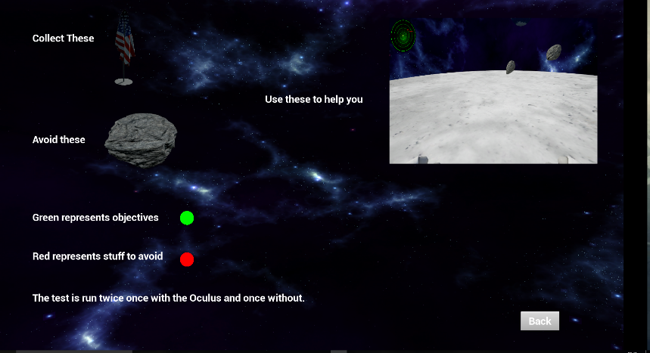

Figure 12. Instructions Screen.

Calibrate Oculus

During this stage of the procedure the user will be sat at the desk and run through the configuration of the Oculus headset, this is done to make sure the head tracking and user position is correct, it is also good for new commoners to VR to get experience in a controlled environment, during the configuration it is made sure the user can freely look directly behind them without cables tangling as to not disrupt the experiment and allow them the full range of motion in the game.

The height of the user is collected and the headset is comfortable fitted to the users head, advance settings such as IPD [14] is not required due to the experiment not investigate emersion and thus the picture quality will suffice with the default configuration.

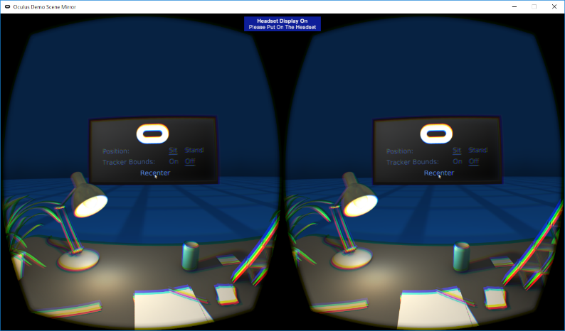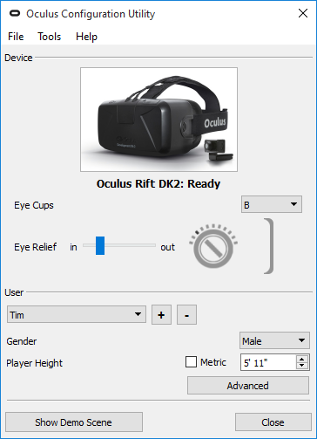Fg 13, 14 show the Configuration tool and scene displayed to the user.

Figure 13. Configuration scene.

Figure 14. Configuration tool.

Game Demo

The user is now given the choice to play a demo of the game, this is a much simplified version of the real experiment without metric tracking, far less projectiles to avoid and the interfaces appear in a set order, the purpose of the demo is to allow users to get used to how the experiment operates such as how the player moves around the arena and how the interfaces convey information.

The demo runs for a much shorter period than the real experiment to reduce over exposure to the system.

Game Scenario

The experiment itself puts the user in arena which they have to manoeuvre about collecting flags (waypoints) while avoiding being hit by asteroids (projectiles), the user is given five different interfaces to help them perform the task they are as follows.

Diegetic

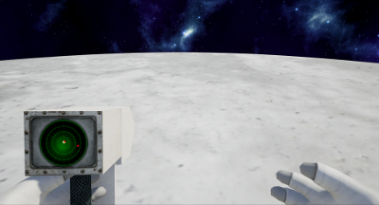The users holds in their hand a radar device that highlights to them where the waypoints and are located and incoming projectiles this interface can be looked away from and therefore can appear in and out of view Fg 15 shows the interface.

Figure 15. Diegetic interface.

Non Diegetic

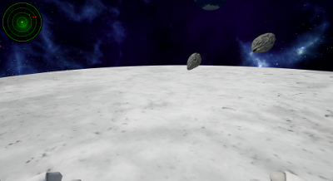The user is given a radar that appears permanently in the top right of their view, the waypoints and projectiles are displayed on the interface, the interface orientates to the players rotation and displays them in the middle of the interface, Fg 16 shows the interface.

Figure 16. Non diegetic interface.

Spatial

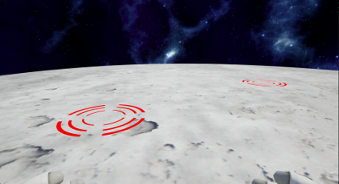The user is presented with targets that appear on the ground showing where the projectiles are targeting, also the waypoints have a target placed beneath them, Fg 17 shows the interface.

Figure 17. Spatial interface.

Meta

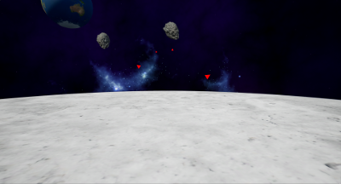The user is presented with a temporary interface that appears when either the projectile or the waypoint is in range, the arrows that represent these entity’s increase in size depending on their distance from the user. Fg 18 shows the interface.

Figure 18. Meta interface.

No Interface

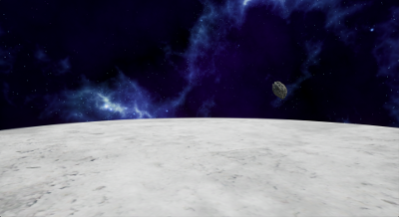The user is left in the game arena with no interface to help them performing the task, this is used as a control for the experiment. Fg 19 shows the game world without any interface.

Figure 19. No interface.

To make sure the experiment focuses on how the Oculus impacts the user performing the task, the user performs the experiment once with the Oculus and once with the Oculus for each of the interfaces, this allows us to collect data and draw correlations as to whether the Oculus remains the same for user performance or whether a specific interface has lower/higher performance than a standard setup.

The player moves around the game world using an Xbox360 controller, this helps to keep the movement consistent across both mediums and reduces the complexity.

To make sure the game is challenging enough to gather good metrics multiple projectiles approach the player at the same time, the projectiles also have varied behaviour some seek out the player while others target a random area in the arena, the waypoints appear in various predefined locations in the game world this is so that we can tell where a player is moving from, for example player has just collected waypoint three which we know the location of and will now be looking to move towards waypoint four this helps with the metrics we will be observing that is explained in a later section, for most instances of the waypoints the next place for the player to move to will not be in their direct view on collecting the antecedent waypoint, thus forcing them to rely on their interface or looking around the game arena.

The interfaces are randomised for each run of the experiment, each interface appears for ninety seconds to aid the user bringing the total run time of the experiment to fifteen minutes.

Metrics to be collected

Similar to the other experiments stated in section X, we track the following metrics for data synthesis.

* The total number of asteroids the player has dodged, this is split between the different types of asteroids mentioned previously the has an algorithm for working out whether the player was ever in danger and being hit and made an effort to dodge the given projectile.
* The number of asteroids that hit the player are tracked.
* The time it takes for the player to move between to waypoint locations is tracked, this lets us see how quickly the player identified the next waypoint and how long it took them to move there.
* The total number of waypoints the player visits during each interface is tracked.
* The player’s movement is tracked over the experiment to see whether they are moving or standing still, movement shows progress towards the objective while no motion shows the player accessing their current situation.

Post experiment questionnaire.

Now that we have gathered quantitative data the final questionnaire will be used to collect qualitative data from the users as shown in the background section the research by Kevin and Christopher [8] a questionnaire was filled in at the end of each interface test, this would add to much time to this experiment and therefore has been cut down and merged to form the post experiment questionnaire , the following questions will be included in the questionnaire, a copy of the full questionnaire see Appendix B.

Post experiment questions.

* Rank the interfaces in order with 5 being the worst and 1 being the best which helped you perform at your best when using the Oculus rift.
* How often did you use your most preferred interface to make decisions?
* Why was the interface you chose as number 5 your least preferred?
* How often did you use your least preferred interface to make decisions?

The previous questions are repeated for the non-oculus version of the experiment.

Further post experiment questions

The user is now presented with a set of statements which they answer Oculus rift, Non Oculus rift or Not sure.

* I felt I performed at my best when using.
* I felt I had to concentrate more when using.
* I felt I stood still more using.
* I enjoyed the experiment more when using.
* I felt the interfaces worked better when using.
* I felt the experiment was more intuitive using.
* I found the experiment more difficult using.
* I felt more confident using.

The final section of the post experiment questionnaire is general questions about the experiment and how the user agrees on a scale from strongly disagree to strongly agree.

* The game felt responsive.
* The game was fun.
* I understood my objective at all times.
* The interfaces were well made.
* The interfaces were easy to understand.
* The experiment took too long.
* I enjoyed my experience using the Oculus rift.
* The Xbox controller was easy to use.
* The game felt challenging but not impossible.
* I felt I performed at my best.
* Any addition comments?

From these questions we can then begin to compare the qualitative and quantitative data and begin to draw conclusions as to the best interfaces to use on the Oculus.

Results and Analysis

(Collected results, how they were gathered, critical analysis of significance of the results, ideally by comparing with existing results)

Conclusions

References

[1] <https://www.unrealengine.com/blog>.

[2] <https://www.oculus.com/en-us/>.

[3] <http://www.thewanderlust.net/2010/03/29/user-interface-design-in-video-games/>

[4] <https://en.wikipedia.org/wiki/List_of_games_with_Oculus_Rift_support>

[5] <https://en.wikipedia.org/wiki/Razer_Hydra>

[6] <http://www.gamasutra.com/view/news/194145/Video_Designing_Dead_Spaces_immersive_user_interface.php>

[7] Erik Fagerholt, Magnus Lorentzon. 'Beyond the HUD User Interfaces for Increased Play Immersion in FPS Games'. *Chalmers University of Technology* (2009) Pg 30-32.

[8] Browne, Kevin, and Christopher Anand. 'An Empirical Evaluation Of User Interfaces For A Mobile Video Game'. *Entertainment Computing* 3.1 (2012). Web.

[9] Nielsen, J. and Philips, V. (1993) Estimating the relative usability of two interfaces: Heuristic, Formal, and empirical Methods Compared. InterCHI 93, ACM.

[10] A. B. Oving and J. B. F. Van Erp, “Driving with a head-slaved camera system,” in Proc. Hum. Factors EErgonom. Soc. 45th Annu. Meet, 2001, pp. 1372-1376

[11] Card, S.K., Moran, T.P., and Newell, A. (1983). *The Psychology of Human-Computer Interaction.* Erlbaum Associates, Hillsdale, NJ.

[12] <http://www.economist.com/blogs/schumpeter/2014/03/facebook-buys-oculus-vr-0>

[13] <https://www.evevalkyrie.com/>

[14] <https://forums.oculus.com/community/discussion/6704/important-improve-image-quality-with-ipd-adjusters>

Appendices

Appendix A

23/04/2016 Pre Experiment Questionnaire

Pre Experiment Questionnaire  
Thank you for participating in this experiment, please attempt to answer all questions as accurately as possible.  
* Required  
  
Questions  
Background Information on previous experience of the participant.

1. What is your gender? * Mark only one oval.

Female

Male

1. What is your age? *
2. In the past 7 days, roughly how many hours have you spent playing video games (e.g. gaming consoles, mobile phones, computers, etc.)? * Mark only one oval.

None

1 to 3 hours

4 to 6 hours

7 to 9 hours

10 hours or more

* 1. do not play video games

1. What genres of games do you play? * Check all that apply.

Massively multi player online

Shooter

Adventure

Role­Playing

Simulation

Strategy

Survival horror

* 1. do not play video games

1. In the past 7 days how many hours have you spent playing first person games? * Mark only one oval.

None

1 to 3 hours

4 to 6 hours

7 to 9 hours

10 hours or more

* 1. do not play video gams

1. What is your experience with the Oculus rift? * Mark only one oval.
   1. have never heard of the Oculus rift

I have heard of the Oculus rift but never used one

I have used an Oculus rift

1. How many hours have you spent using an Oculus rift? Mark only one oval.

None

1 to 3 hours

4 to 6 hours

10 hours or more

* 1. have not used an Oculus rift

Appendix B

Post experiment questionnaire

Questions to be answered after the completion of the experiment on the users experience when using the Oculus rift.

* Required

Interfaces

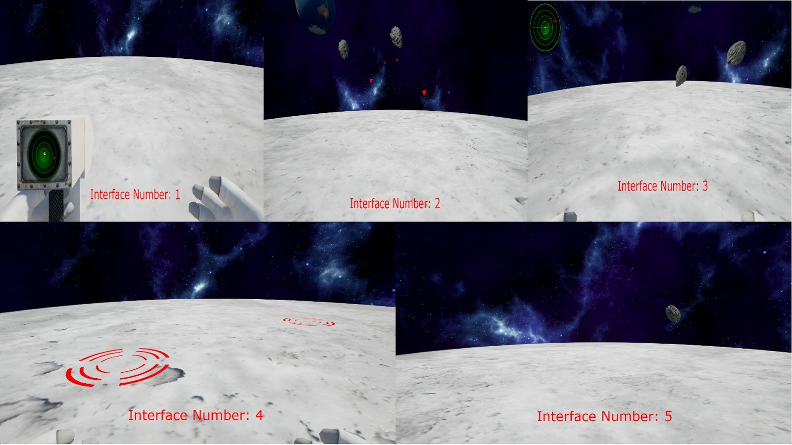

1. Rank the interfaces in order with 5 being the worst and 1 being the best, which helped you perform at your best when using the Oculus rift. * Mark only one oval per row.

5

4

3

2

1

Interface Number 1

Interface Number 2

Interface Number 3

Interface Number 4

Interface Number 5

1. Why was the interface you chose as number 1 your most preferred? * Check all that apply.

It helped me to perform at my best.

It helped me identify the projectiles.

It was easy to use and understand.

It effected my choices.

* 1. could rely on it.

It wasn't intrusive.

It was much better than the other interfaces.

Other:

1. How often did you use your most preferred interface to make decisions? * Mark only one oval per row.

Never Rarely Sometimes Often Very Often

Interface 1 Usage

1. Why was the interface you chose as number 5 your least preferred? * Check all that apply.

It did not help me perform at my best.

It did not help me identify the projectiles.

It was not easy to use and understand.

It did not effect my choices.

* 1. could not rely on it.

It was intrusive.

It was much worse than the other interfaces.

Other:

1. How often did you use the interface to make decisions? * Mark only one oval per row.

Never Rarely Sometimes Often Very Often

Interface 5 Usage

Post experiment questionnaire

Questions to be answered after the completion of the experiment on the users experience when not using the Oculus rift.

Interfaces



1. Rank the interfaces in order with 5 being the worst and 1 being the best, which helped you perform at your best when not using the Oculus rift. * Mark only one oval per row.

5

4

3

2

1

Interface Number 1

Interface Number 2

Interface Number 3

Interface Number 4

Interface Number 5

1. Why was the interface you chose as number 1 your most preferred? * Check all that apply.

It helped me to perform at my best.

Interface 1 Usage

It helped me identify the projectiles.

It was easy to use and understand.

It effected my choices.

* 1. could rely on it.

It wasn't intrusive.

It was much better than the other interfaces.

Other:

1. How often did you use the interface to make decisions? * Mark only one oval per row.

Never Rarely Sometimes Often Very Often

1. Why was the interface you chose as number 5 your least preferred? * Check all that apply.

It did not help me perform at my best.

It did not help me identify the projectiles.

It was not easy to use and understand.

It did not effect my choices.

* 1. could not rely on it.

It was intrusive.

It was much worse than the other interfaces.

Other:

1. How often did you use the interface to make decisions? * Mark only one oval per row.

Never Rarely Sometimes Often Very Often

Interface 5 Usage

Comparison of performance.

Questions on which median the user preferred for a series of statements.

1. Please pick the median which completes the statement. * Mark only one oval per row.

Oculus Rift

No Oculus Rift

Notsure

I felt I performed at my best when

using...

I felt I had to concentrate more

when using...

I felt I stood still more using...

I enjoyed the experiment more

when using...

I felt the interfaces worked better

when using...

I felt the experiment was more

intuitive when using...

I found the experiment more

difficult when using...

I felt more confident using...

General questions.

General questions about the users experience with the experiment.

1. Please answer the following on your experience of the experiment. * Mark only one oval per row.

Strongly

disagree

Disagree

Neither agree

nor disagree

Agree

Strongly

agree

The game felt

responsive.

The game was fun.

I understood my

objective at all times.

The interfaces were

well made.

The interfaces were

easy to understand.

The experiment took

too long.

I enjoyed my

experience using the

Oculus rift.

The Xbox controller

was easy to use.

The game felt

challenging but not

impossible.

I felt I performed at my

best.

13

.

Any additional comments.

